Broughton Moor Parish Council – Financial Information for y/e 31.03.2018

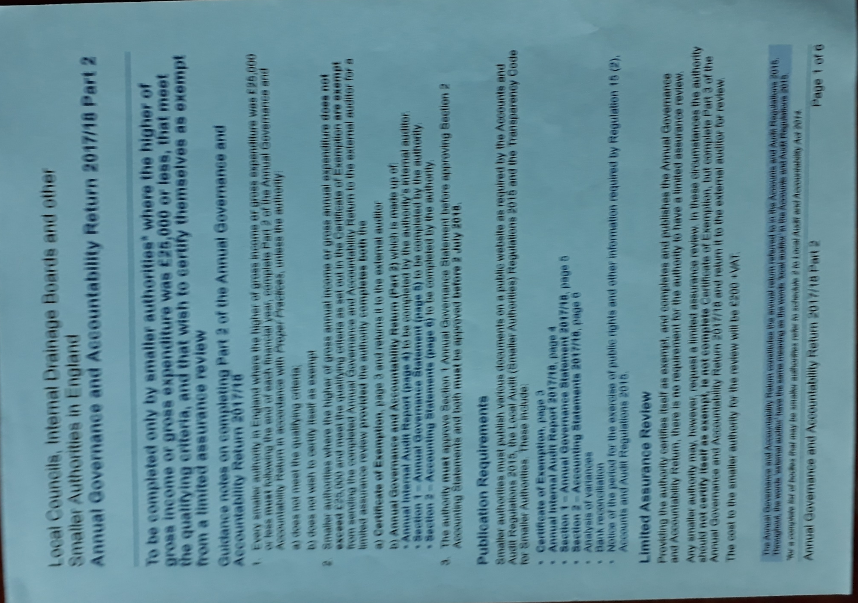

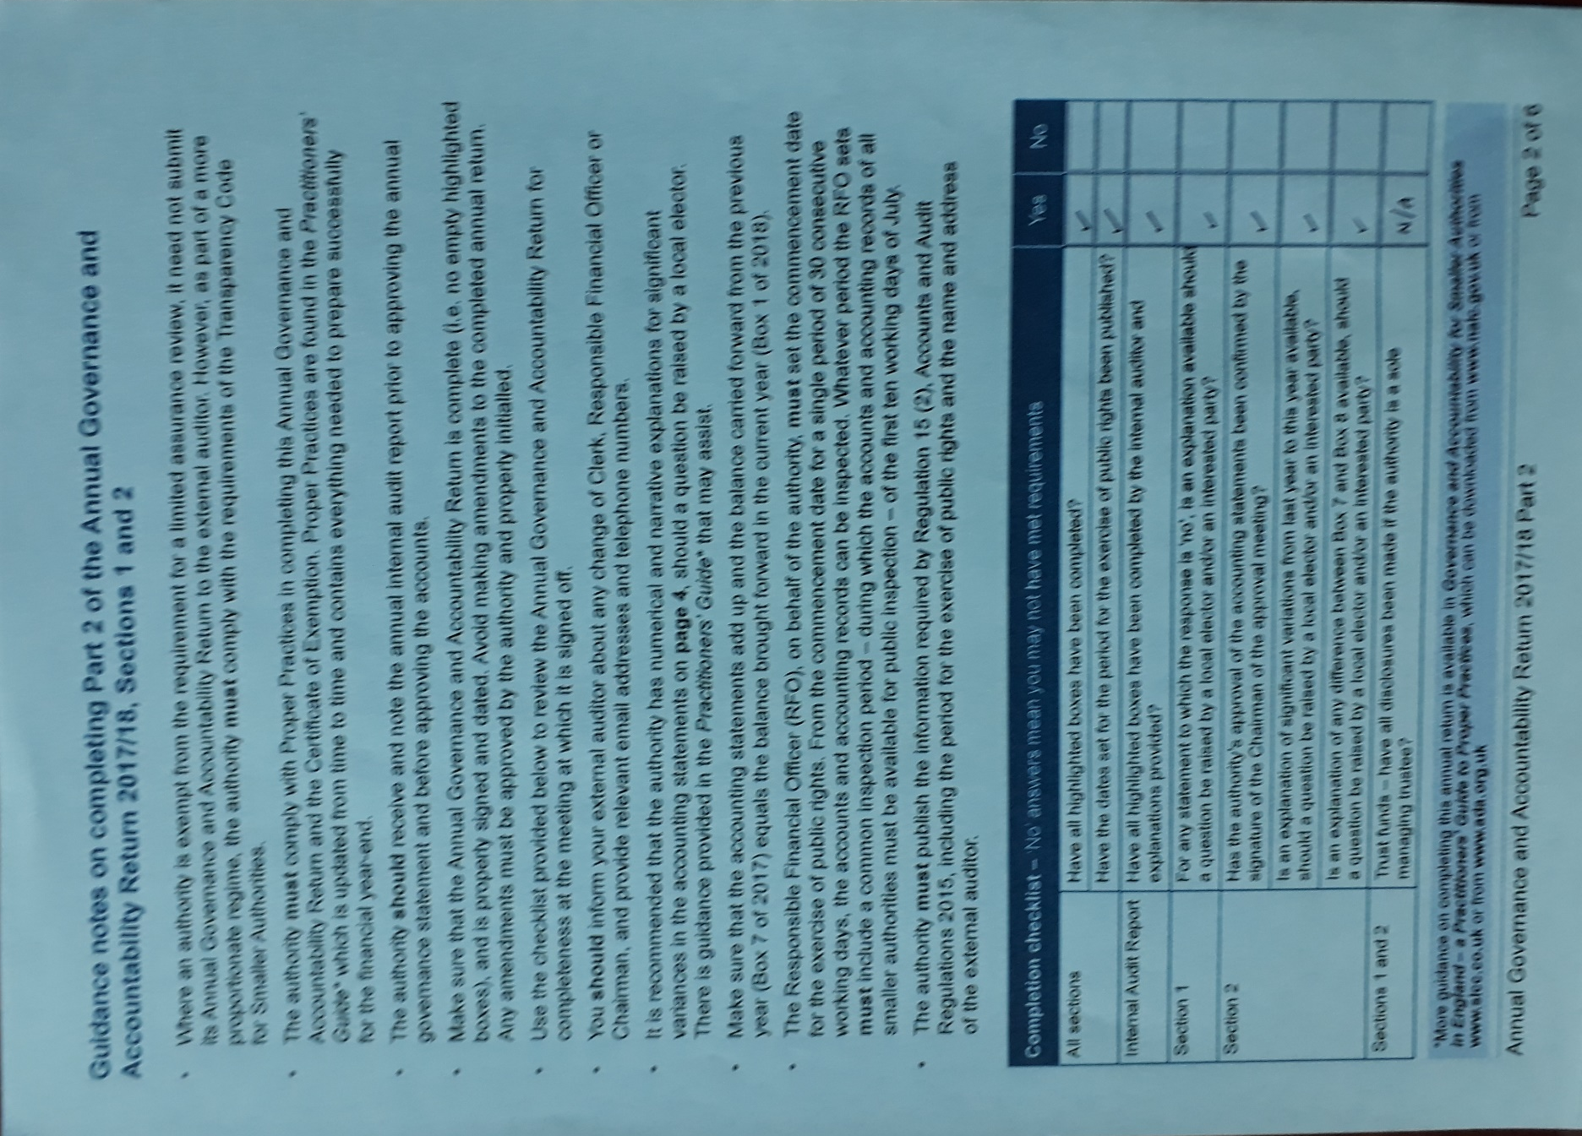

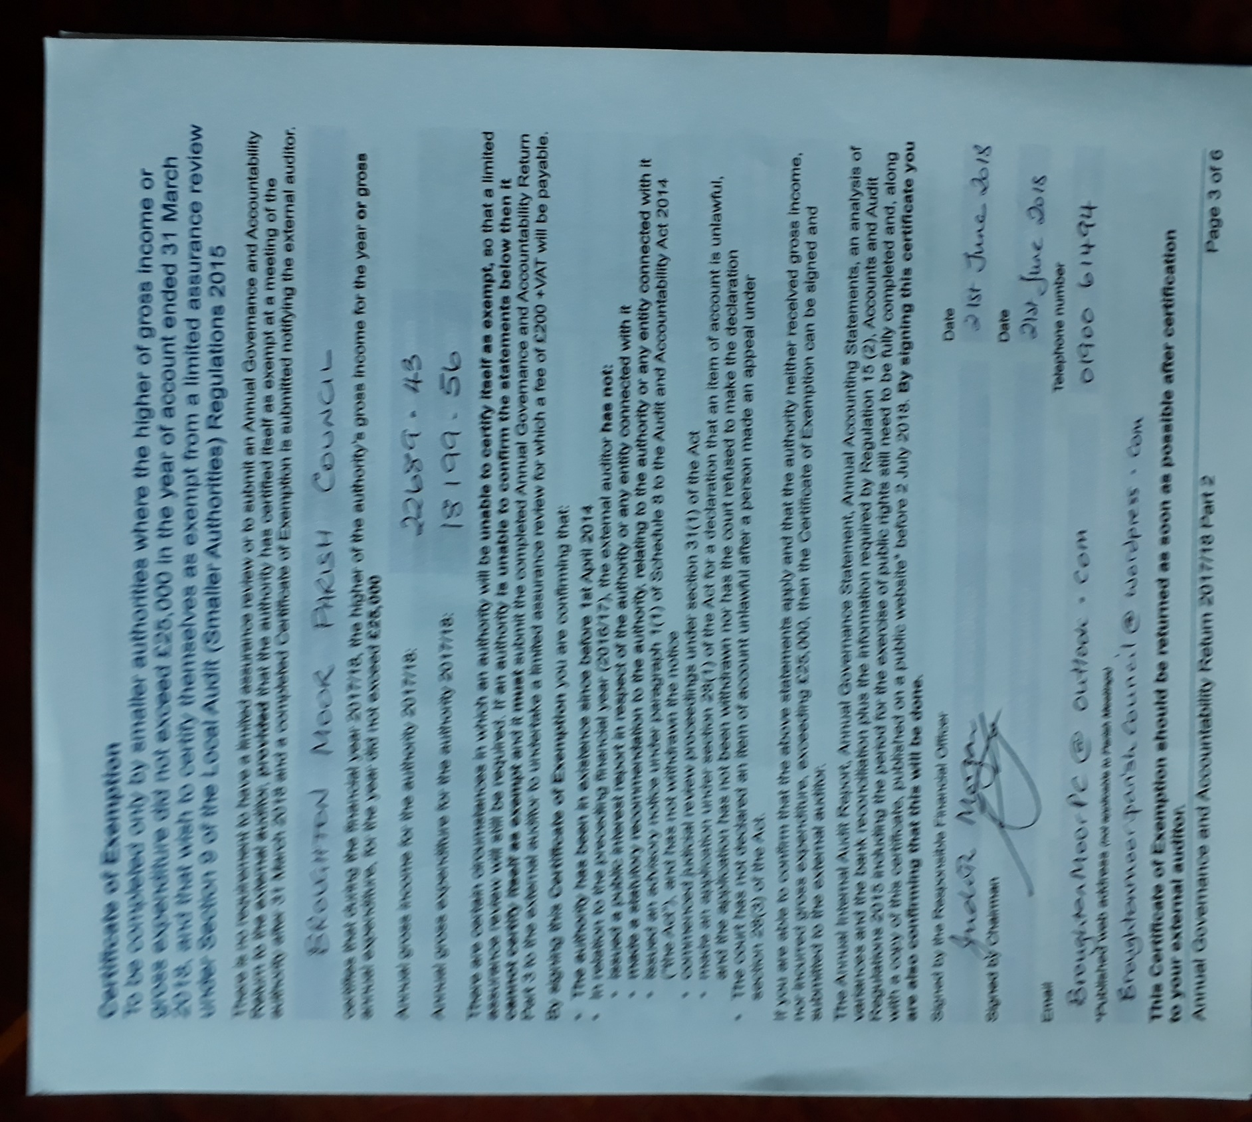

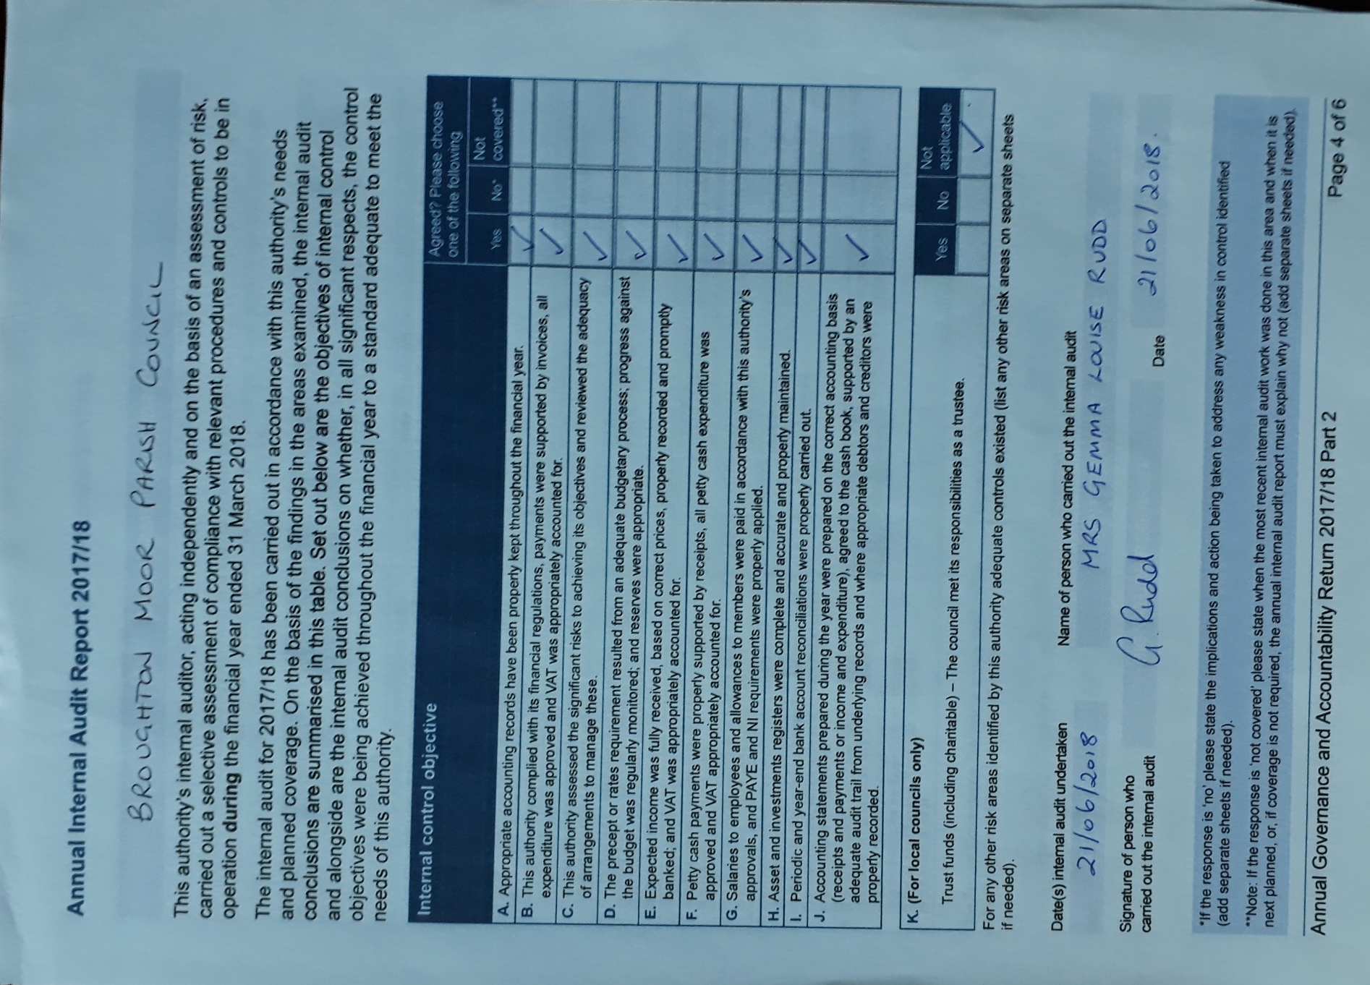

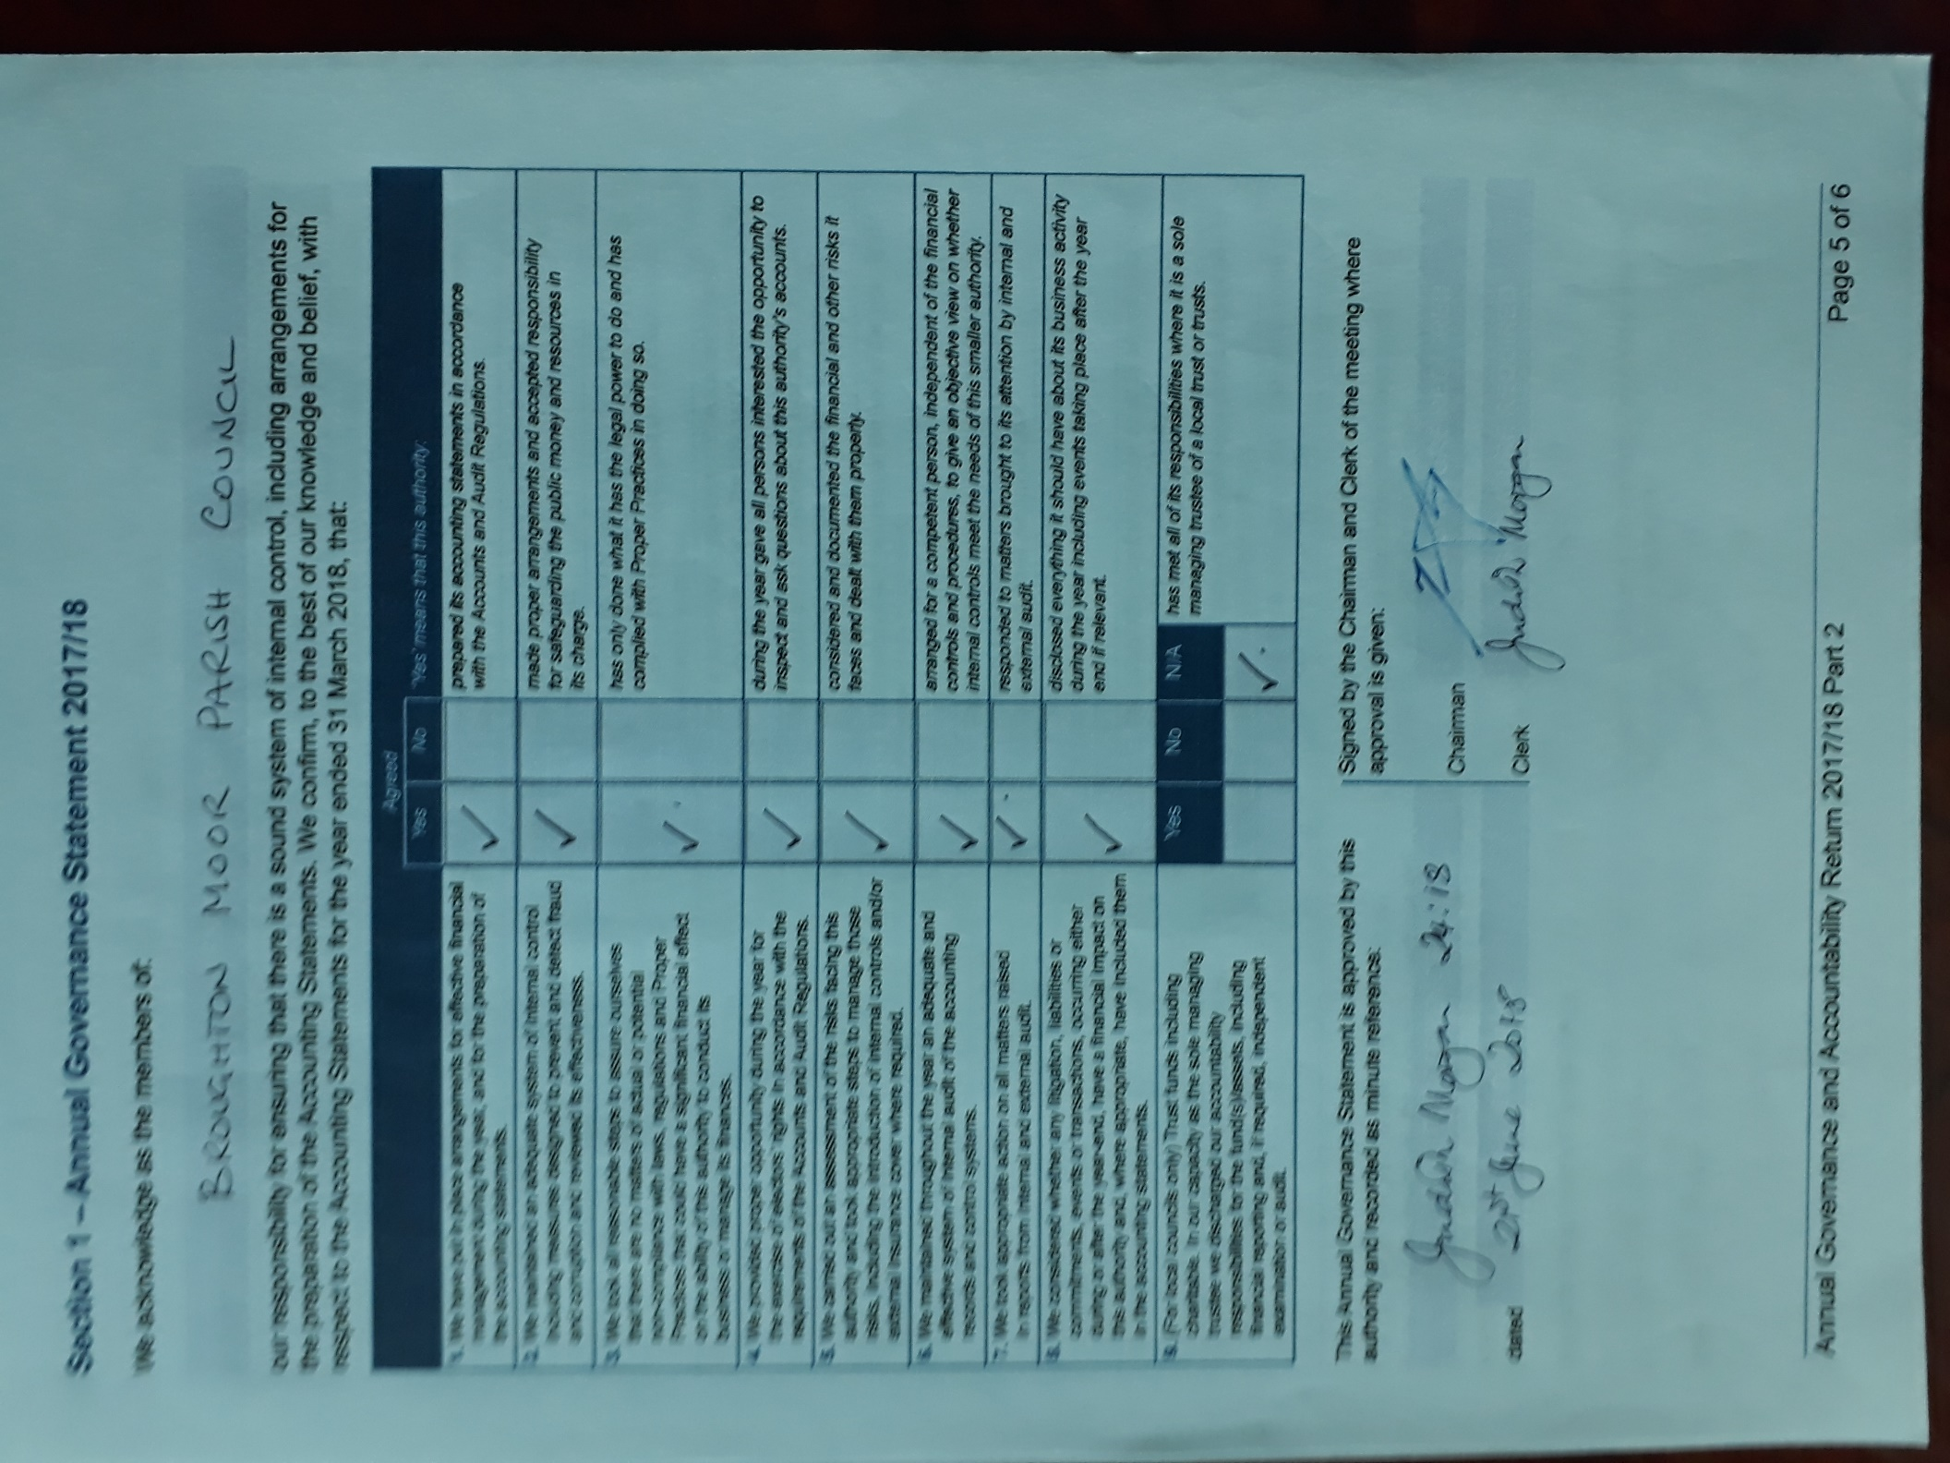

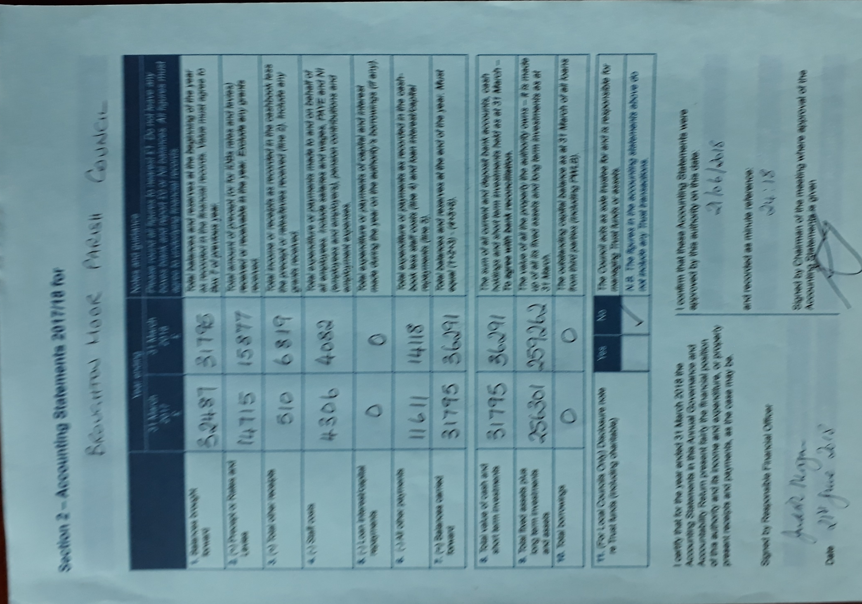

Broughton Moor Parish Council
Bank Reconciliation as at 31st March 2018

Prepared by J Morgan, Parish Clerk

Current account:

Balance as per bank statement 31.3.18 25295.20
Less outstanding cheques at 31.3.18 ( 1509.89)
Add balance on treasurer’s account 31.3.18 12505.88
Net balance at 1 April 2018 36291.19

Cash Book

Opening balance at 1st April 2017 31795.39
Add receipts during the year 22695.36
Less expenditure in the year (18199.56)

Closing balance as at 31st March 2018 36291.19

Broughton Moor Parish Council
Receipts and Payments Account
Year ended 31st March 2018

Receipts
Precept 15876.66
Concurrent Grant 323.34
Vat Refund 577.10
CCF Grant 5912.33
Bank Interest 5.93
22695.36

Payments
General Administration:
Salaries 3183.84
PAYE 794.40
Calc Subs 218.28
Aon Insurance 1352.03
Audit fee (internal Auditor) 40.00
Audit fee (external Auditor) 120.00
DBO LLP
Chairman’s Expenses 200.00
Postage and stationary and
Office expenses 748.68
6657.23

Bus Shelters 895.64
Field Maintenance 2828.22
Play equipment (RoSPA inspection) 100.80
Grants and Donations
West Lakes Squirrel Initiative 200.00
RBL wreath and poppy appeal 42.00
GNAAS 50.00 292.00

Christmas Tree Event 907.37

Community Centre:
Gas and electricity 323.34
Milburns’ solicitors 240.00
New light fittings 519.00
Gas boiler plan 284.28
New office door lock 31.00
Handyman services 75.00
New hand-drier and fitting of same 546.80
New Tea Urn 138.00 2157.42

Tennis Court:
New tables and benches 2961.60
Fitting of same 956.24
Planters (Dalston aggregates) 259.00 4176.84
New locks for noticeboard 184.04
Total expenditure 18199.56

In year surplus £3395.80 Subject to audit.
Broughton Moor Parish Council

Significant Variances to the accounts for the year ended 31st March 2018

Income

The Parish Council received a VAT refund of £577.10 during the year.

A grant of £5912.33 was received from Cumbria Community Foundation for environmental improvements in the parish.

Expenditure

The Parish Council spent a total of £895.64 on bus shelter maintenance and repairs during the year,
as this was long overdue.

Expenditure on field maintenance totalled £2828.22 in the year.

Replacement locks were purchased for the village noticeboard, at a cost of £184.04

Expenditure on tables and benches plus decorative planters, soil and plants, totalled £4176.84 from the Cumbria Community Foundation grant (see Income, above).

Grants and donations totalled £292.00 for the year.

Spending on the Community Centre was as follows:
Gas and electricity 323.34
Milburns’ solicitors 240.00
New light fittings 519.00
Gas boiler plan 284.28
New office door lock 31.00
Handyman services 75.00
New hand-drier and fitting of same 546.80
New Tea Urn 138.00 2157.42

Judith Morgan
Parish Clerk

Smaller authority name: BROUGHTON MOOR PARISH COUNCIL
NOTICE OF PUBLIC RIGHTS AND PUBLICATION OF ANNUAL GOVERNANCE & ACCOUNTABILITY RETURN (EXEMPT AUTHORITY)
ACCOUNTS FOR THE YEAR ENDED 31 MARCH 2018

Local Audit and Accountability Act 2014 Sections 25, 26 and 27
The Accounts and Audit Regulations 2015 (SI 2015/234)
NOTICE | NOTES
1. Date of announcement____2nd June 2018____________________________________(a)  2. Each year the smaller authority prepares an Annual Governance and Accountability Return (AGAR). The AGAR has been published with this notice. It will not be reviewed by the appointed auditor, since the smaller authority has certified itself as exempt from the appointed auditor’s review.  Any person interested has the right to inspect and make copies of the AGAR, the accounting records for the financial year to which it relates and all books, deeds, contracts, bills, vouchers, receipts and other documents relating to those records must be made available for inspection by any person interested. For the year ended 31 March 2018, these documents will be available on reasonable notice by application to:  (b) Rev’d Judith Morgan, Parish Clerk,  30 Queens Avenue  Seaton  Workington  Tel (01900) 61494  commencing on (c) __Monday 4 June 2018 _______________________  and ending on (d) ___Friday 13 July 2018 ________________________  3. Local government electors and their representatives also have:  - The opportunity to question the appointed auditor about the accounting records; and  - The right to make an objection which concerns a matter in respect of which the appointed auditor could either make a public interest report or apply to the court for a declaration that an item of account is unlawful. Written notice of an objection must first be given to the auditor and a copy sent to the smaller authority.  The appointed auditor can be contacted at the address in paragraph 4 below for this purpose between the above dates only.  4. The smaller authority’s AGAR is only subject to review by the appointed auditor if questions or objections raised under the Local Audit and Accountability Act 2014 lead to the involvement of the auditor. The appointed auditor is:  PKF Littlejohn LLP (Ref: SBA Team)  1 Westferry Circus  Canary Wharf  London E14 4HD  (sba@pkf-littlejohn.com)  5. This announcement is made by (e) Rev’d Judith Morgan, Parish Clerk | (a) Insert date of placing of the notice which must be not less than 1 day before the date in (c) below  (b) Insert name, position and address/telephone number/ email address, as appropriate, of the Clerk or other person to which any person may apply to inspect the accounts  (c) Insert date, which must be at least 1 day after the date of announcement in (a) above and at least 30 working days before the date appointed in (d) below  (d) The inspection period between (c) and (d) must be 30 working days inclusive and must include the first 10 working days of July.  (e) Insert name and position of person placing the notice – this person must be the responsible financial officer for the smaller authority

