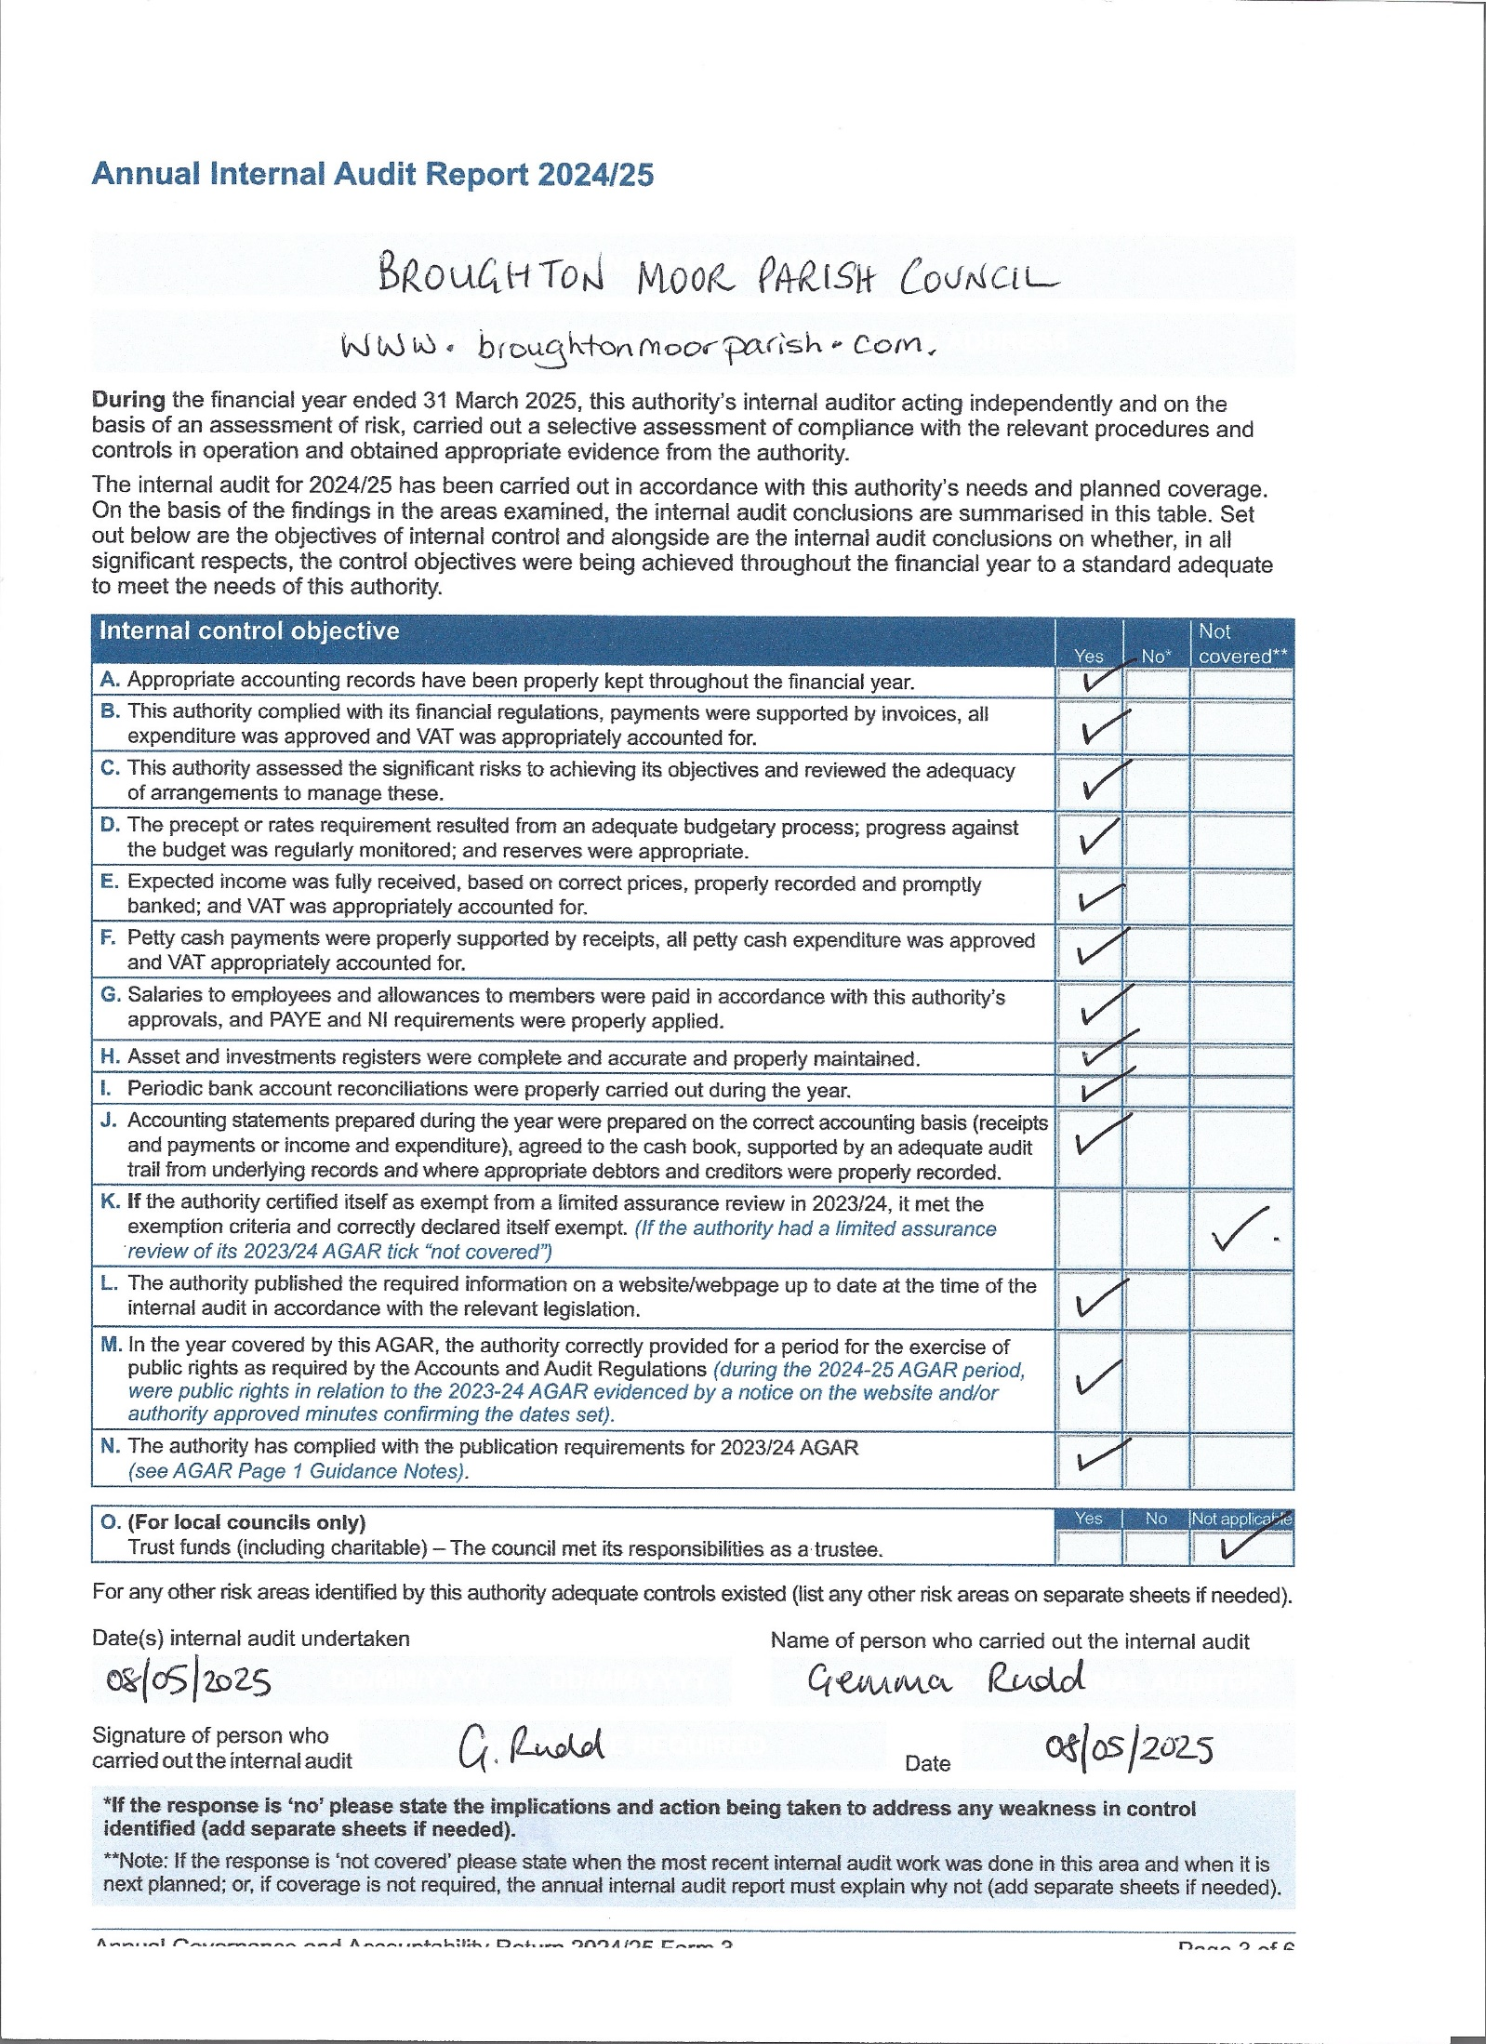
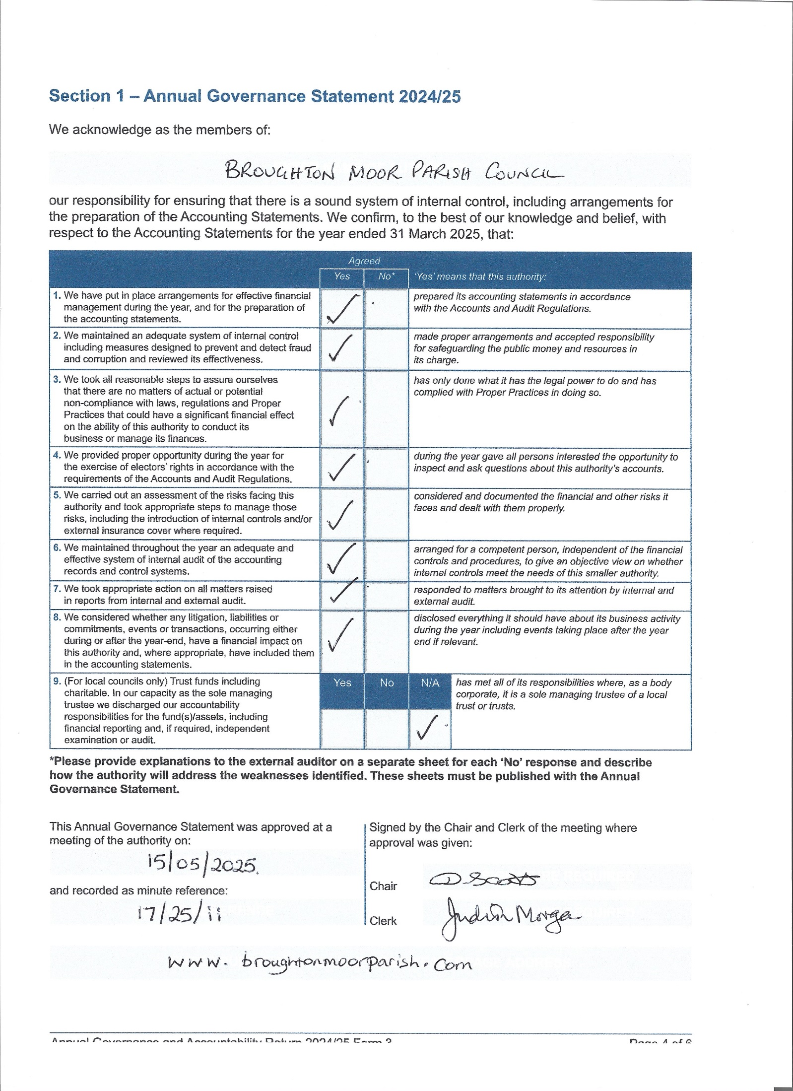
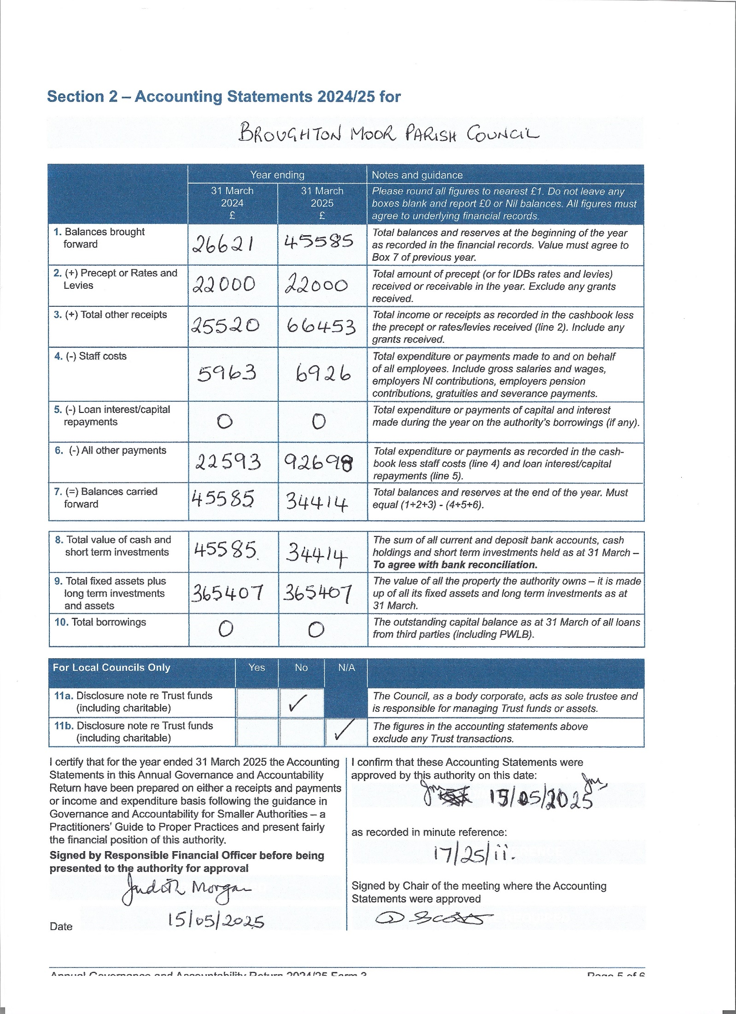
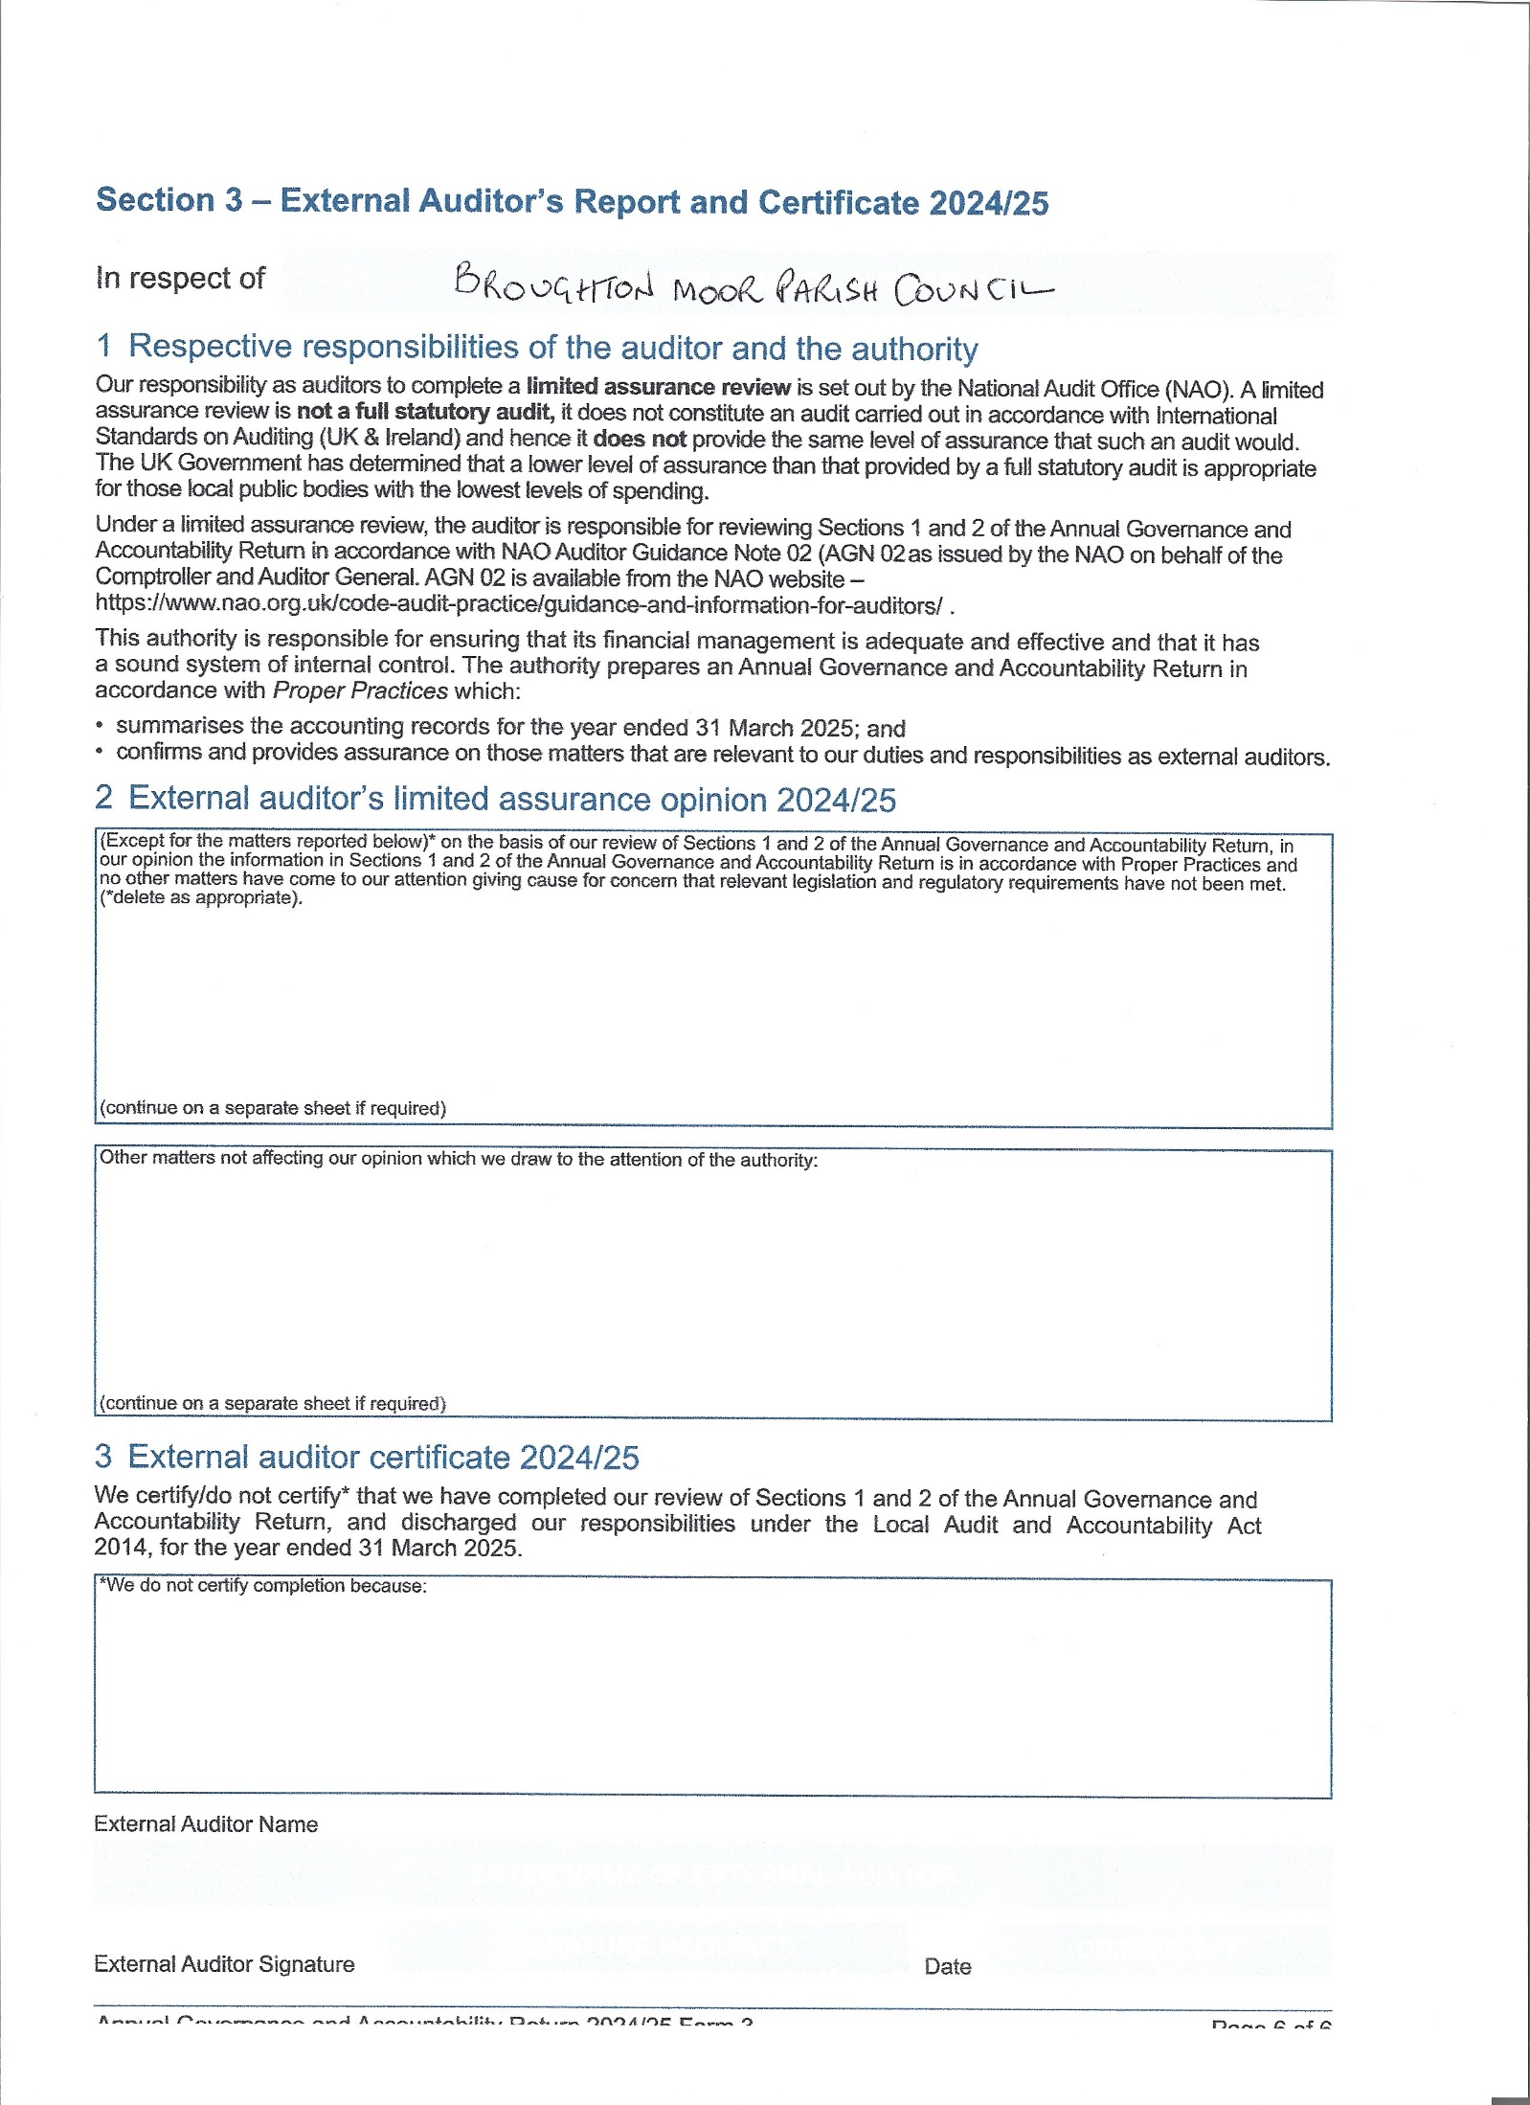
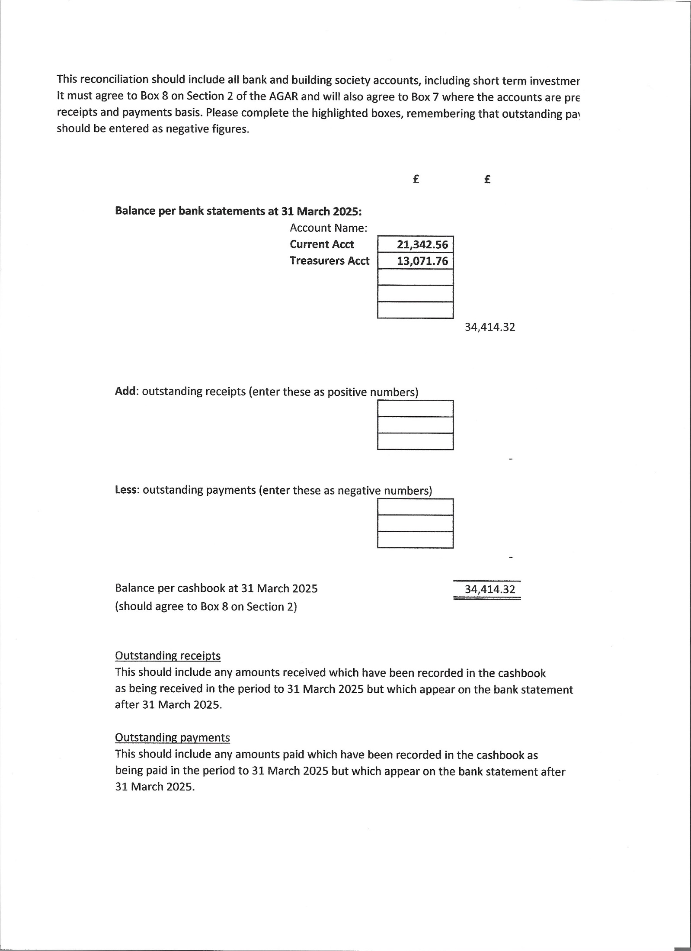
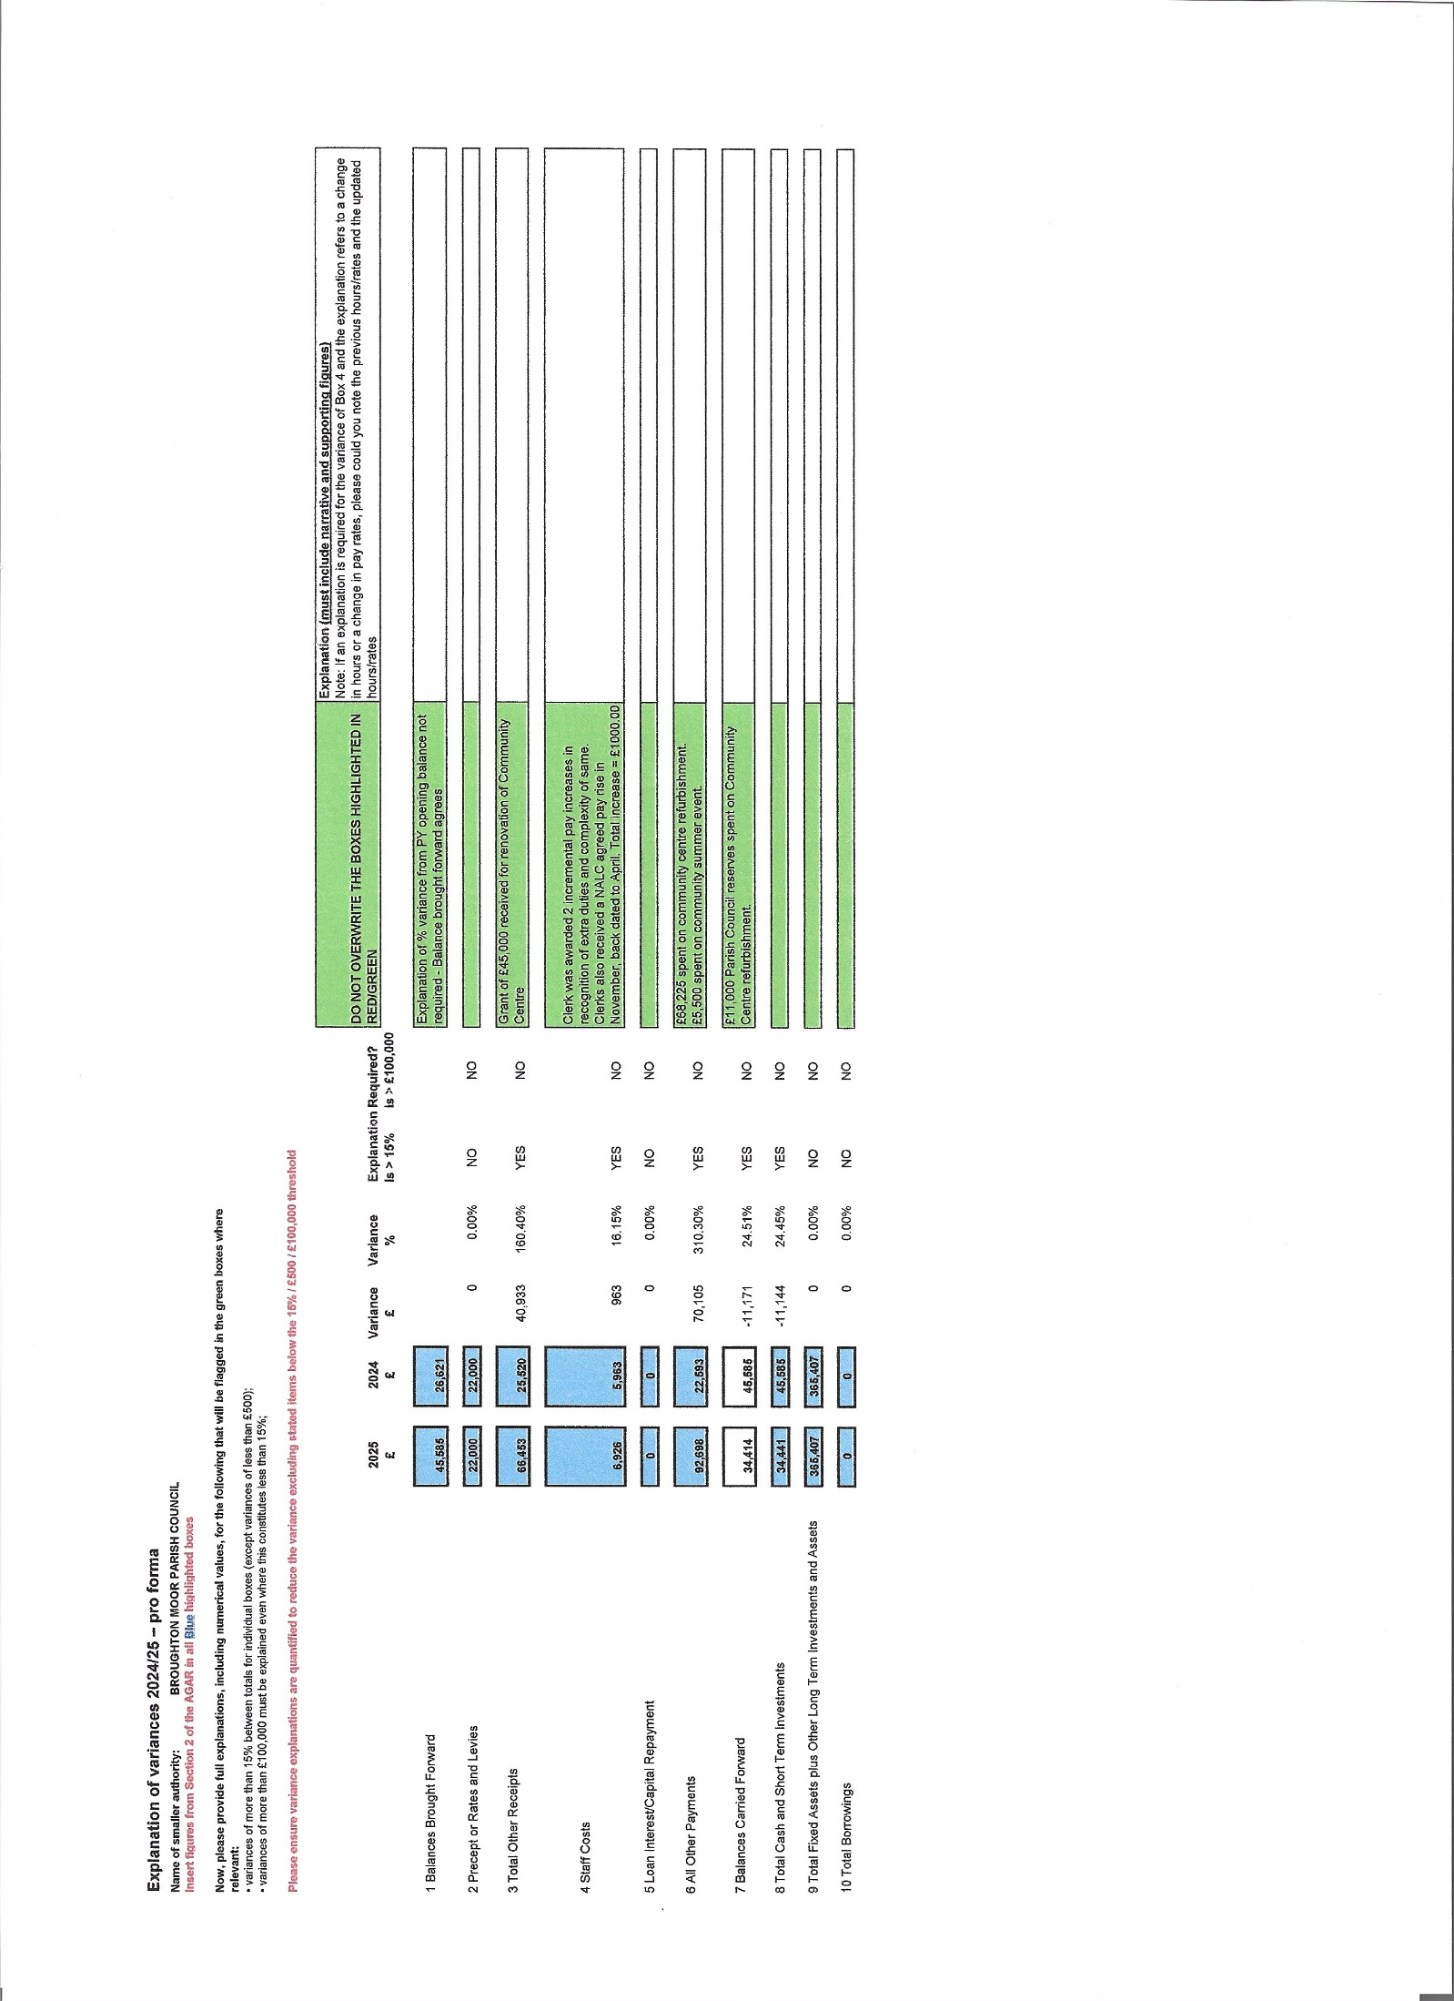
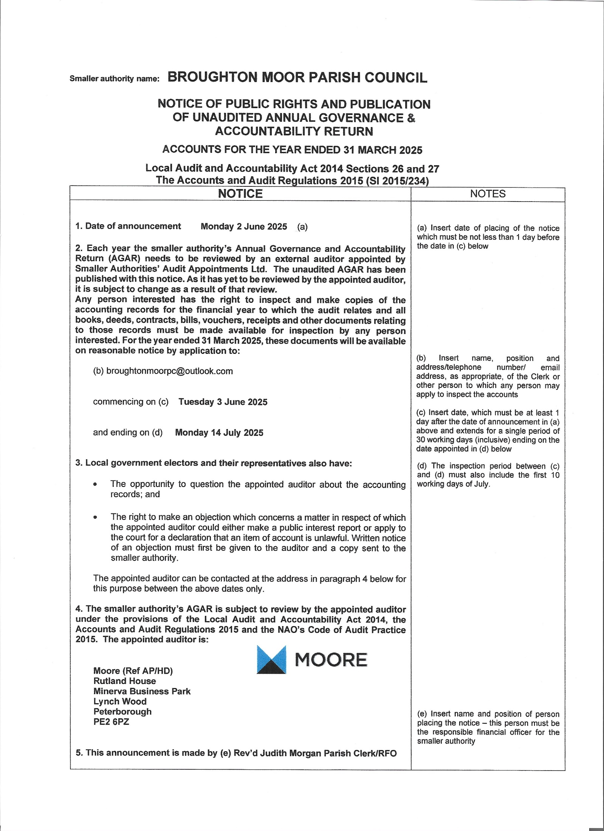
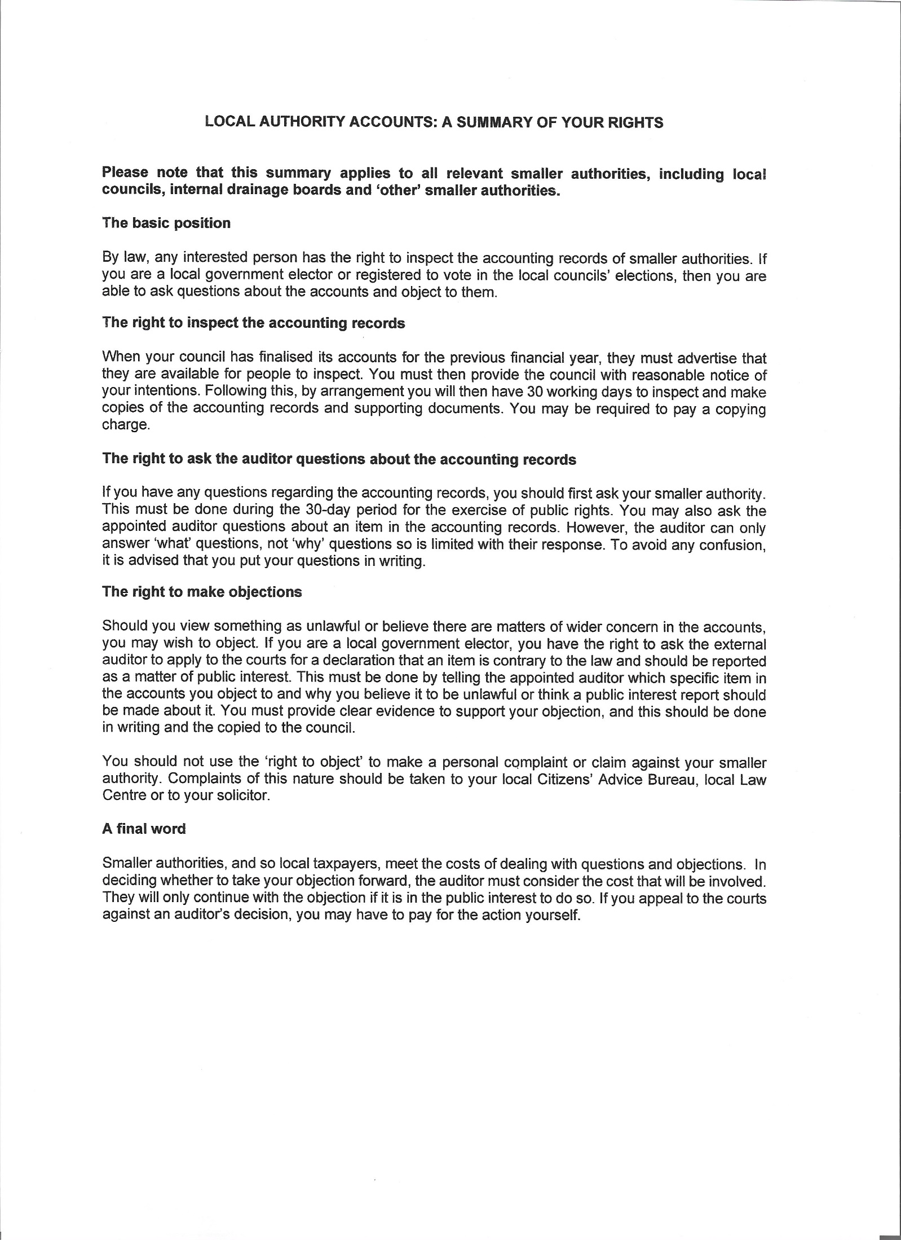

Smaller Authority Name: BROUGHTON MOOR PARISH COUNCIL

NOTICE OF CONCLUSION OF ANNUAL AUDIT

ACCOUNTS FOR THE YEAR ENDED 31 MARCH 2025
Accounts and Audit Regulations 2015

- The audit of accounts for Broughton Moor Parish Council
for the year ended 31 March 2025 has been completed and the accounts have been published.

- The Annual Return is available for inspection by any local government elector in the area of Broughton Moor Parish Council
on application to

- Rev’d Judith Morgan
Parish Clerk

- 30 Queens Avenue, Seaton, Workington, CA14 1DL

Hours by appointment – telephone 07903236024

- Copies will be provided to any person on payment of £1 for each copy of the Annual Return

Announcement made by (Name of Clerk)
Rev’d Judith Morgan

Date of Announcement
September 2025

