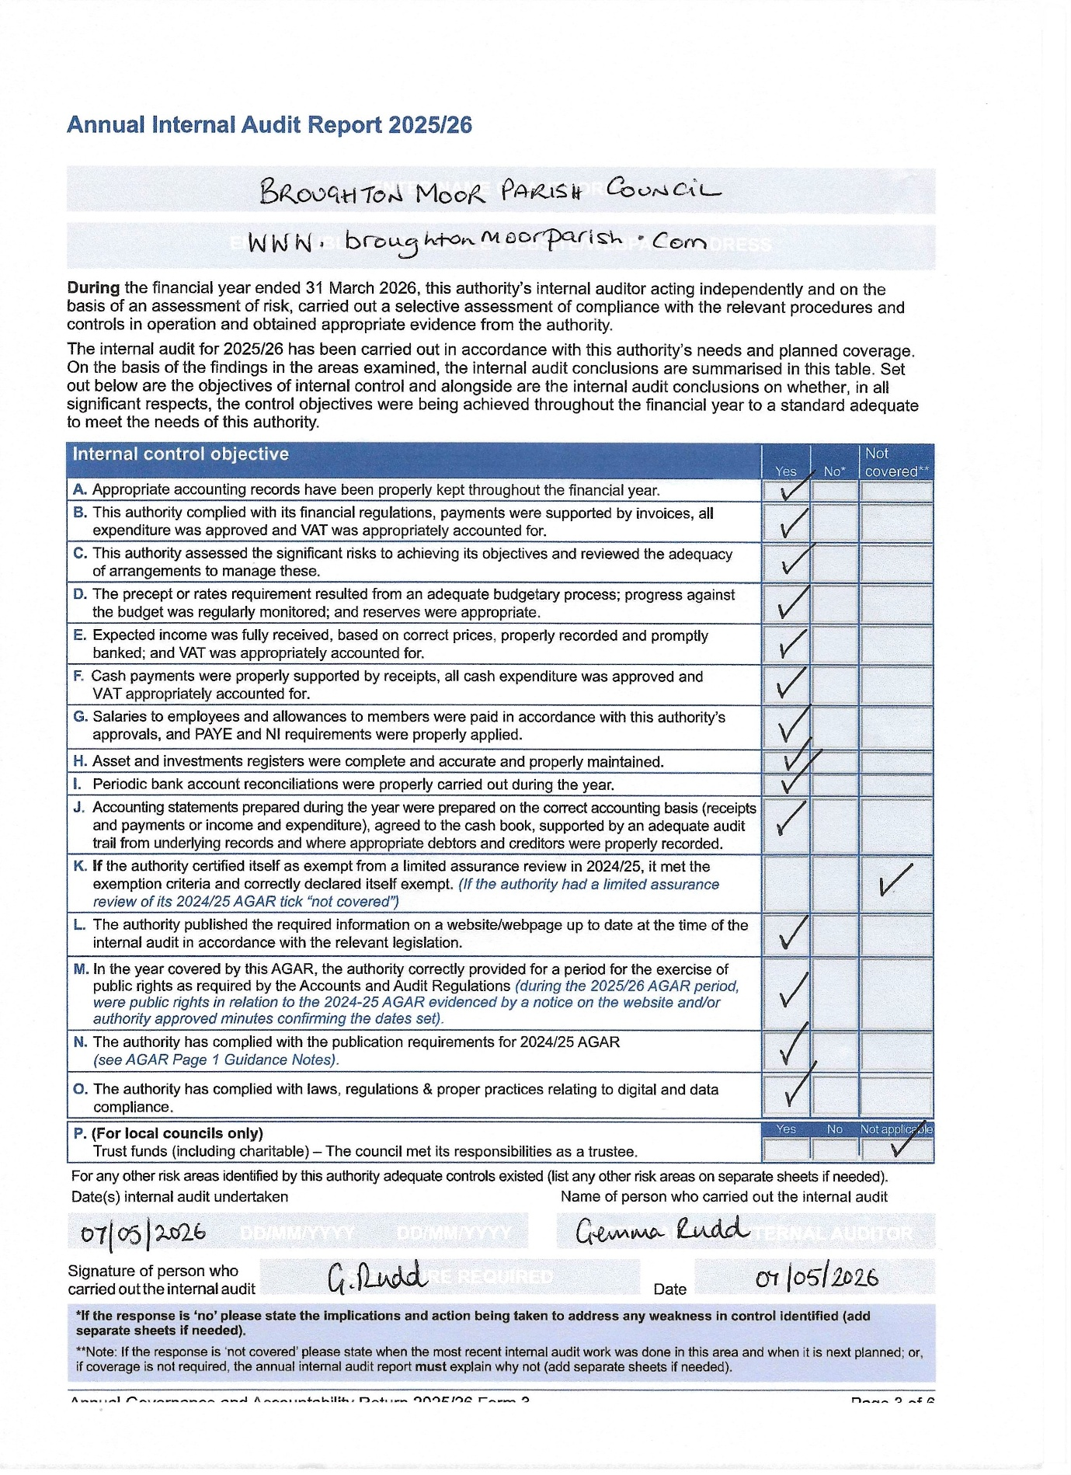
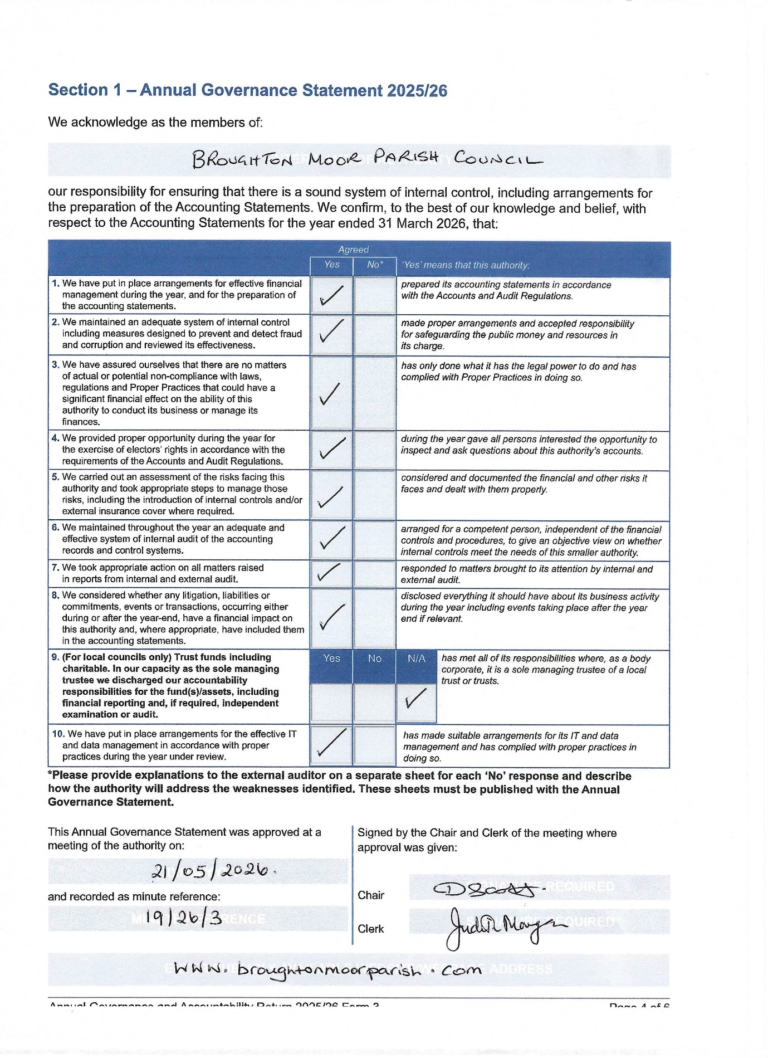

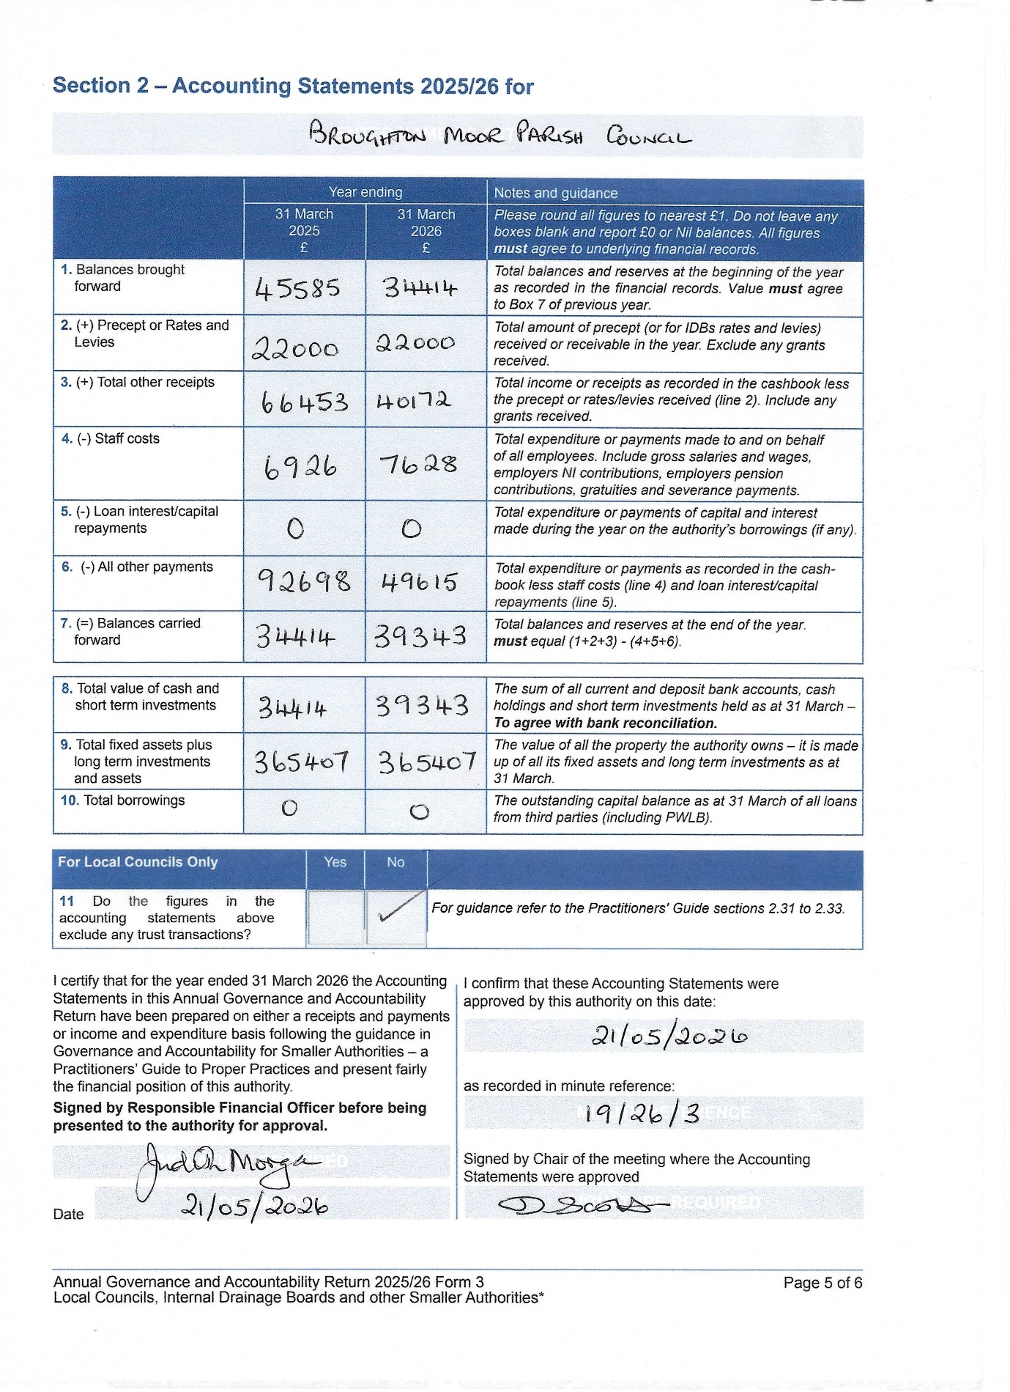

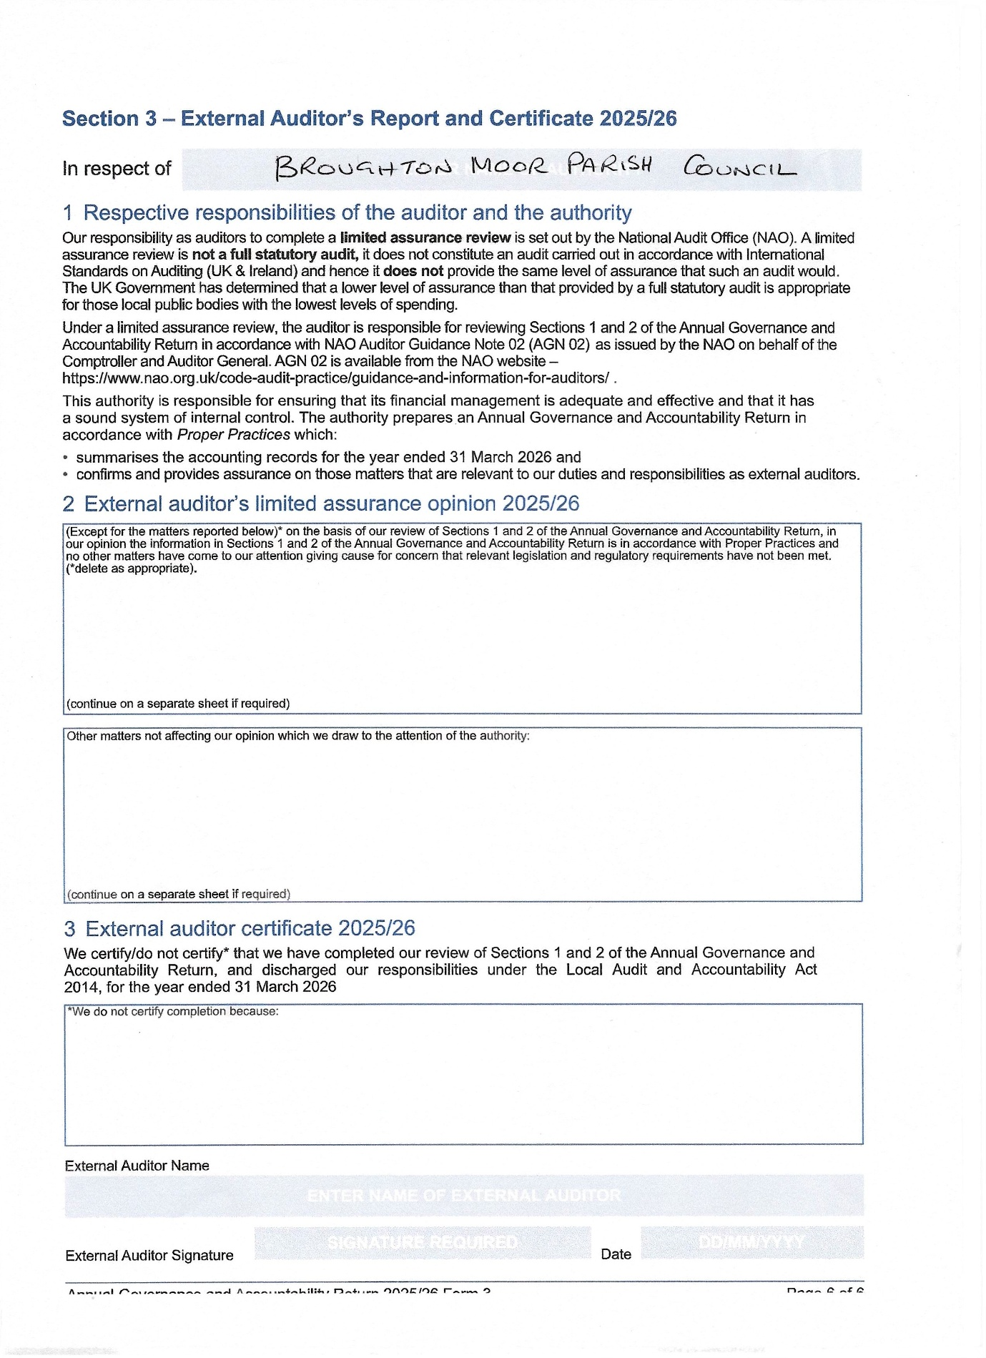

Smaller authority name: Broughton Moor Parish Council

NOTICE OF PUBLIC RIGHTS AND PUBLICATION OF UNAUDITED ANNUAL GOVERNANCE & ACCOUNTABILITY RETURN
ACCOUNTS FOR THE YEAR ENDED 31 MARCH 2026

Local Audit and Accountability Act 2014 Sections 26 and 27
The Accounts and Audit Regulations 2015 (SI 2015/234)
NOTICE | NOTES
1. Date of announcement Tuesday 2 June 2026 (a)  2. Each year the smaller authority’s Annual Governance and Accountability Return (AGAR) needs to be reviewed by an external auditor appointed by Smaller Authorities’ Audit Appointments Ltd. The unaudited AGAR has been published with this notice. As it has yet to be reviewed by the appointed auditor, it is subject to change as a result of that review.  Any person interested has the right to inspect and make copies of the accounting records for the financial year to which the audit relates and all books, deeds, contracts, bills, vouchers, receipts and other documents relating to those records must be made available for inspection by any person interested. For the year ended 31 March 2026, these documents will be available on reasonable notice by application to:  (b) Rev’d Judith Morgan, Parish Clerk 07903236024  commencing on (c) _ Wednesday 3 June 2026 ___________________  and ending on (d) ___Tuesday 14 July 2026 _________________ _  3. Local government electors and their representatives also have:  - The opportunity to question the appointed auditor about the accounting records; and  - The right to make an objection which concerns a matter in respect of which the appointed auditor could either make a public interest report or apply to the court for a declaration that an item of account is unlawful. Written notice of an objection must first be given to the auditor and a copy sent to the smaller authority.  The appointed auditor can be contacted at the address in paragraph 4 below for this purpose between the above dates only.  4. The smaller authority’s AGAR is subject to review by the appointed auditor under the provisions of the Local Audit and Accountability Act 2014, the Accounts and Audit Regulations 2015 and the NAO’s Code of Audit Practice 2015. The appointed auditor is:  Moore East Midlands (Ref AP/HD)   Rutland House  Minerva Business Park  Lynch Wood  Peterborough  PE2 6PZ  5. This announcement is made by (e) Rev’d Judith Morgan, Parish Clerk | (a) Insert date of placing of the notice which must be not less than 1 day before the date in (c) below  (b) Insert name, position and address/telephone number/ email address, as appropriate, of the Clerk or other person to which any person may apply to inspect the accounts  (c) Insert date, which must be at least 1 day after the date of announcement in (a) above and extends for a single period of 30 working days (inclusive) ending on the date appointed in (d) below  (d) The inspection period between (c) and (d) must also include the first 10 working days of July.  (e) Insert name and position of person placing the notice – this person must be the responsible financial officer for the smaller authority

LOCAL AUTHORITY ACCOUNTS: A SUMMARY OF YOUR RIGHTS

Please note that this summary applies to all relevant smaller authorities, including local councils, internal drainage boards and ‘other’ smaller authorities.

The basic position

By law, any interested person has the right to inspect the accounting records of smaller authorities. If you are a local government elector or registered to vote in the local councils’ elections, then you are able to ask questions about the accounts and object to them.
The right to inspect the accounting records

When your council has finalised its accounts for the previous financial year, they must advertise that they are available for people to inspect. You must then provide the council with reasonable notice of your intentions. Following this, by arrangement you will then have 30 working days to inspect and make copies of the accounting records and supporting documents. You may be required to pay a copying charge.

The right to ask the auditor questions about the accounting records

If you have any questions regarding the accounting records, you should first ask your smaller authority. This must be done during the 30-day period for the exercise of public rights. You may also ask the appointed auditor questions about an item in the accounting records. However, the auditor can only answer ‘what’ questions, not ‘why’ questions so is limited with their response. To avoid any confusion, it is advised that you put your questions in writing.
The right to make objections

Should you view something as unlawful or believe there are matters of wider concern in the accounts, you may wish to object. If you are a local government elector, you have the right to ask the external auditor to apply to the courts for a declaration that an item is contrary to the law and should be reported as a matter of public interest. This must be done by telling the appointed auditor which specific item in the accounts you object to and why you believe it to be unlawful or think a public interest report should be made about it. You must provide clear evidence to support your objection, and this should be done in writing and the copied to the council.

You should not use the ‘right to object’ to make a personal complaint or claim against your smaller authority. Complaints of this nature should be taken to your local Citizens’ Advice Bureau, local Law Centre or to your solicitor.

A final word

Smaller authorities, and so local taxpayers, meet the costs of dealing with questions and objections. In deciding whether to take your objection forward, the auditor must consider the cost that will be involved. They will only continue with the objection if it is in the public interest to do so. If you appeal to the courts against an auditor’s decision, you may have to pay for the action yourself.

Section 3 - External Auditor Report and Certificate 2024/25
In respect of Broughton Moor Parish Council

Respective responsibilities of the auditor and the authority
Our responsibility as auditors to complete a limited assurance review is set out by the National Audit Office (NAO). A limited assurance review is not a full statutory audit, it does not constitute an audit carried out in accordance with International Standards on Auditing (UK & Ireland) and hence it does not provide the same level of assurance that such an audit would. The UK Government has determined that a lower level of assurance than that provided by a full statutory audit is appropriate for those local public bodies with the lowest levels of spending.
Under a limited assurance review, the auditor is responsible for reviewing Sections I and 2 of the Annual Governance and Accountability Return in accordance with NAO Auditor Guidance Note 02 (AGN 02) as issued by the NAO on behalf of the Comptroller and Auditor General. AGN 02 is available from the NAO website — https://www.nao.org.uk/code-auditpractice/guidance-and-information-for-auditors/
This authority is responsible for ensuring that its financial management is adequate and effective and that it has a sound system of internal control. The authority prepares an Annual Governance and Accountability Return in accordance with Proper Practices which
- summarises the accounting records for the year ended 31 March 2025; and
- confirms and provides assurance on those matters that are relevant to our duties and responsibilities as external auditors

External auditor limited assurance opinion 2024/25
Except for the matters reported below on the basis of our review of Sections I and 2 of the Annual Governance and Accountability Return, in our opinion the information in Sections 1 and 2 of the Annual Governance and Accountability Return is in accordance with the Proper Practices and no other matters have come to our attention giving cause for concern that relevant legislation and regulatory requirements have not been met.
Section 16(1) of the Accounts and Audit Regulations 2015 requires the Notice of Conclusion of Audit to be published on the authority's website. In future, the council should ensure that this notice IS available on their website alongside the signed external audit report and the audited AGAR
This point was also raised on the prior year External Auditor Report and therefore points raised by the external auditor have not been appropriately actioned. The council should therefore have provided a 'No' response to Assertion 7 on the 2024/25 Annual Governance Statement
Other matters not affecting our opinion which we draw to the attention of the authority:
The Internal Auditor has provided a 'Yes' response at control objectives L and N on their report. This suggests that the council correctly published all relevant documents on its website. As the council currently has not published the notice of conclusion of audit following the 2023/24 limited assurance review, the answer to these points should have been 'No'
We note that the contact email address does not appear to belong to the council. Paragraph 1.26 of JPAG Practitioners' Guide 2024 states every authority should have an email account that belongs to the council and to which the council has access. An email account that is considered to belong to the council should have an authority owned domain, for example clerk@abcparishcouncil gov.uk or clerk@abcparishcouncil.org.uk. From 1 April 2025 this became a mandatory requirement, and the council will need to consider whether it is fully compliant.

External auditor certificate 2024/25
We certify that we have completed our review of Sections I and 2 of the Annual Governance and Accountability Return, and discharged our responsibilities under the Local Audit and Accountability Act 2014, for the year ended 31 March 2025.
External Auditor Name | External Auditor Signature | Date
coc
MOORE07/08/2025
Page 6 of 6
Annual Governance and Accountability Return 2024/25 Pan 3
Local Councils, Internal Drainage Boards and other Smaller Authorities*

BROUGHTON MOOR PARISH COUNCIL

NOTICE OF CONCLUSION OF ANNUAL AUDIT

ACCOUNTS FOR THE YEAR ENDED 31 MARCH 2026
Accounts and Audit Regulations 2015

- The audit of accounts for Broughton Moor Parish Council
for the year ended 31 March 2026 has been completed and the accounts have been published.

- The Annual Return is available for inspection by any local government elector in the area of Broughton Moor Parish Council
on application to

- Rev’d Judith Morgan
Parish Clerk

- 30 Queens Avenue, Seaton, Workington, CA14 1DL

Hours by appointment – telephone 07903236024

- Copies will be provided to any person on payment of £1 for each copy of the Annual Return

Announcement made by (Name of Clerk)
Rev’d Judith Morgan

Date of Announcement
1st August 2026

